From Dataset to Dashboard
A plain-language walkthrough of what we did, how we did it, and what ended up on the screen
See the dashboard https://jeet-1236.github.io/walmart-sales-intelligence/
See the code https://github.com/jeet-1236/walmart-sales-intelligence

1. What this project is
We were given four spreadsheets of Walmart sales data. We joined them into one table, checked the data for problems, ran eight pieces of analysis on it, and turned the results into a dashboard that anyone can open in a web browser.
This document explains that journey in plain words. It is about the process. If you want the findings themselves, read the companion document, “Walmart Sales Intelligence”.
The short version: the data covers 45 stores and 81 departments over 143 weeks, which is 421,570 rows in total. Every number on the dashboard traces back to one of those rows.
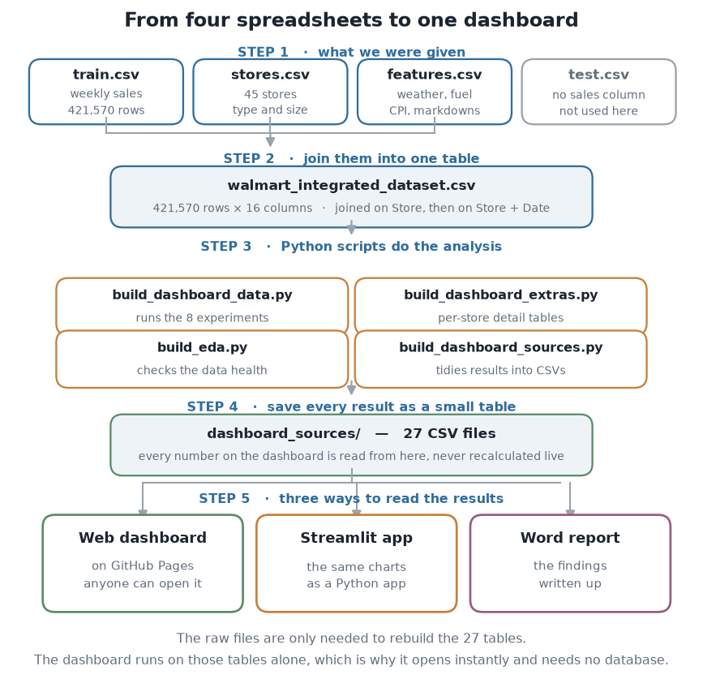
Figure 1. The whole project on one page. Each step is explained below.

2. What we started with
Four files. Here is what each one holds and whether we used it.
File | What is inside | Did we use it?
train.csv | Weekly sales for each store and each department. This is the thing we are trying to understand. | Yes, this is the main file
stores.csv | One row per store: which of the three types it is (A, B or C) and how big it is in square feet. | Yes
features.csv | One row per store per week: temperature, fuel price, the local cost-of-living index, unemployment, and five markdown (discount) columns. | Yes
test.csv | The same shape as train.csv but with the sales column removed. It exists for a prediction competition. | No. With no sales figures there is nothing to analyse.

A note on the word “department”
A department is a section of the shop, like groceries or electronics. They are only given as numbers, not names, so throughout this project a department is referred to as “Department 92” and so on. We have no way to know what it sells.

3. Joining the files into one table
Analysis is much easier when everything sits in one table, so that was the first job. We did it in two steps.
- Add the store information. Each sales row says which store it came from, and the store file has one row per store. We matched them on the store number. Now every sales row also knows its store type and size.
- Add the weekly conditions. The features file has one row per store per week. We matched on the store number and the date together, because we need the right week as well as the right store. Now every sales row also knows that week's temperature, fuel price and so on.
The result is walmart_integrated_dataset.csv: 421,570 rows and 16 columns. One row is “one department, in one store, in one week”. That sentence is worth remembering, because it explains a lot of what follows.
We checked that the join did not accidentally duplicate anything. The combination of store, department and date appears exactly once across all 421,570 rows, so the table is clean.

4. Cleaning it up
Four small fixes, each for a reason.
- Dates. They arrived as plain text like “2010-02-05”. We converted them into real dates so the computer can sort them, work out which week of the year they fall in, and put them on a timeline.
- The holiday marker. It arrived as the words TRUE and FALSE. We turned it into a proper yes/no value.
- The discount columns. They arrived as text with gaps. We turned them into numbers. The gaps matter a great deal and we come back to them in the next section.
- Rows with no sales figure. Dropped, because there is nothing to analyse in them.

5. Checking the data before trusting it
Before running any analysis we looked at the data itself. In statistics this is called exploratory data analysis, or EDA. The point is to find problems early, so that you do not build a conclusion on top of a fault.
We wrote a script that goes through every column and reports: how many values are missing, how many different values there are, the average, the middle value, the smallest and largest, and how lopsided the spread is. Here is what it found.

Finding 1: most rows are incomplete, and it is all discounts
Only 23% of rows have a value in every column. That sounds alarming until you see which columns are to blame: all five discount columns and nothing else. They are empty for the first two years and only start being recorded in November 2011.
This matters for one specific reason. Inside the period where discounts are recorded, every single row has one. So the data never shows us a week with no discount to compare against. Any claim of the form “sales with a discount versus sales without one” cannot be made from this data, because the “without” group does not exist.
We only discovered this because we profiled the original files. The joined file fills those gaps with zeros, and a zero looks like “we discounted nothing” when the truth is “nobody wrote it down”. Those are very different things.

Finding 2: a few impossible values
Two of the discount columns contain negative numbers, 1,311 rows in one and 257 in the other. A discount cannot be negative, so these are errors in the source data rather than something to explain. We left them in place and noted them rather than quietly deleting them.

Finding 3: sales are very lopsided
Most weeks are small and a few are enormous. The average weekly sale per department is about $15,981, but the middle value is only $7,612. When the average is twice the middle value, a small number of very large weeks are pulling it up.
By the standard statistical rule for spotting unusual values, 8.4% of rows count as outliers. Normally you might remove outliers. Here you must not: those rows carry 40% of all the money. They are not mistakes, they are the Christmas rush.

Finding 4: the grid has gaps
If every store sold every department every week there would be far more rows than we have. About 81% of that full grid is present. That is normal - not every shop carries every department - but it is worth knowing before comparing stores.

6. The eight pieces of analysis
The project brief asked for eight specific experiments. Here is each one in plain words: what we asked, how we answered it, and what came back.
# | Name | What we actually asked | What came back
1 | Descriptive Statistics | Describe the data. We worked out the middle value, the spread, and which weeks count as unusually big or small. | 8.4% of records are outliers but carry 39.6% of revenue
2 | Linear Regression | Find what predicts sales. We fitted a straight-line relationship between sales and things like temperature, fuel price and store size, to see which of them actually matter. | R² rises from 0.0017 (macro only) to 0.672 at store-week level
3 | Sampling | Check whether a sample is enough. Instead of using all 421,570 rows, can you take a few thousand at random and still get the right answer? We tested several sample sizes against the true figure. | A 10,000-record sample estimates the mean within 0.76%
4 | Clustering (K-Means) | Group the stores. We let the computer sort the 45 stores into groups based on how they behave, rather than telling it the groups in advance. This is called clustering. | Four store archetypes, silhouette 0.265
5 | Probability Distribution | Treat sales as a random quantity. We worked out the chance of a department clearing a given sales figure in a week. | P(sales > $50k) = 0.076, carrying 37% of revenue
6 | Theoretical Distributions | Find which standard distribution fits. Statisticians have a library of standard shapes for data. We tested four of them against the real shape of our sales. | Log-normal fits best (KS 0.097); Normal is rejected
7 | Statistical Inference | Test whether differences are real. When holiday weeks look better than normal weeks, is that a genuine difference or just luck? There are formal tests for this and we ran several. | Holiday lift of 7.1% is significant (p<0.001) but small (d=0.046)
8 | Time Series Analysis | Look at the sales over time. We split the timeline into its long-term direction, its yearly rhythm, and the leftover noise, then used that to forecast the next 14 weeks. | Backtest MAPE 1.8% over 13 held-out weeks

A word on two of them
Experiment 4, grouping the stores, has a judgement call in it. The computer will happily make any number of groups you ask for, so you have to choose. We chose four, partly from a standard chart that shows where adding more groups stops helping, and partly because four groups are easy to describe. A second measure of group quality actually prefers other numbers, so these groups are a useful description rather than a hard rule.
Experiment 8, the forecast, is easy to fool yourself with. If you test a forecast on weeks the model already learned from, it will look brilliant. So we hid the last 13 weeks completely, rebuilt the model on the earlier weeks only, and then asked it to predict the hidden ones. It was off by 1.81% on average. For comparison, simply guessing “the same week last year” is off by 2.04%, so our model wins, but not by a wide margin.

7. Getting the results onto a screen
Here is the part that often gets skipped, and it is the reason the dashboard is fast.
We could have built a dashboard that loads the whole 421,570-row file and does the maths in the browser every time someone opens it. That would be slow and would need a server. Instead, the Python scripts do all the heavy work once and write their answers into 27 small CSV tables. The dashboard then just reads those tables and draws them.
So the split is: Python does the thinking, the browser does the drawing. The 27 tables come to about 300 kilobytes in total, which is smaller than a photograph.
Script | What it does, in plain words
build_dashboard_data.py | Runs all eight experiments and writes every result into one file.
build_dashboard_sources.py | Takes that file and splits it into tidy tables, one per chart.
build_dashboard_extras.py | Adds two bigger tables: week-by-week sales for each store, and each store broken down by department.
build_eda.py | Does the data health check described in section 5.
build_pages.py | Packages the dashboard into a plain web page that can be hosted for free.
build_report_figures.py | Draws the charts used in the written reports.
app.py | A second version of the dashboard, written as a Python app.

8. What the dashboard looks like
The dashboard is laid out the way a business intelligence tool like Power BI or Tableau is laid out: filters down the left, headline numbers across the top, and a grid of charts filling the rest. There is almost no writing on it, because the charts are meant to do the talking.
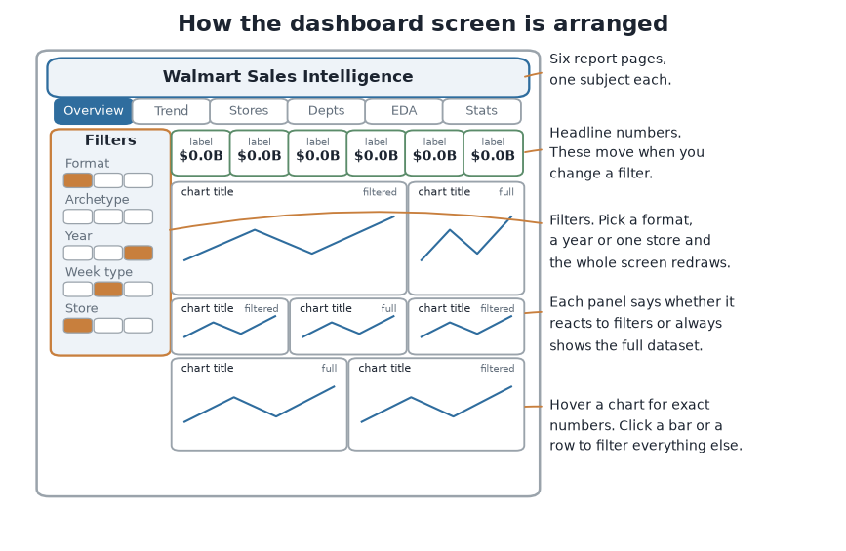
Figure 2. The parts of the screen.

The six pages
Page | What it answers
Overview | How is the business doing overall? Weekly sales, a calendar view of every week, the split by store type, the biggest stores and departments, and a short list of the main findings.
Trend and forecast | How do sales move through the year, and what happens next? The yearly rhythm, the long-term direction, and the 14-week forecast with its accuracy test.
Stores | How do the 45 stores compare? A small chart for every store on the same scale, size against productivity, the store groups, and a sortable table of every store.
Departments | Which departments carry the business? A ranking, a block chart sized by sales, which departments do well at holidays, and a grid showing each store's mix.
EDA profile | Can the data be trusted? Missing values, the shape of every column, the data quality checks from section 5.
Statistics | The formal results. The regression, the sampling tests, the distribution fitting, and the significance tests.

How to use it
- Filters on the left. Pick a store type, a store group, a year, holiday or normal weeks, or a single store. The headline numbers and many of the charts redraw straight away.
- Hover any chart. A small box appears with the exact figures for the point you are pointing at.
- Click to filter. Clicking a bar, a dot, a small store chart or a table row sets that as a filter for the rest of the screen.
- The badge on each panel. Every chart says either “filtered” or “full dataset” in its top corner. This is an honest label, not decoration: charts fed by the pre-calculated tables cannot narrow down, so rather than let them silently ignore your filter, they say so.

9. The tools, and why each one
Tool | What it is | What we used it for
Python | A programming language | Everything in the analysis
pandas | A Python library for tables | Opening the CSV files, joining them, grouping and summarising
NumPy | A Python library for arithmetic | The number-crunching underneath almost everything else
SciPy | A Python library for statistics | The significance tests and the distribution fitting
scikit-learn | A Python library for machine learning | The regression and the store grouping
Matplotlib | A Python library for charts | The charts printed in the written reports
D3.js | A JavaScript charting library | The interactive charts on the web dashboard
Streamlit and Plotly | Tools for building data apps in Python | A second version of the dashboard, for running on a computer
Git and GitHub | Version control and code hosting | Keeping the history of the work and sharing it
GitHub Pages | Free website hosting | Making the dashboard public
python-docx | A Python library for Word files | Building this document

10. Running it yourself
Everything is in the repository. The dashboard itself needs nothing installed - it is a web page. To rebuild the analysis from the raw files, you need Python with the libraries listed above, then run the scripts in this order:
python build_dashboard_data.py
python build_dashboard_sources.py
python build_dashboard_extras.py
python build_eda.py
python build_pages.py
The order matters: the second script reads what the first one writes.

11. Things to keep in mind
Three honest limits, in plain words.
- We cannot judge whether discounts work. As explained in section 5, the data has no discount-free period to compare against. The charts show that bigger discounts go alongside bigger sales, but that is mostly because big departments get big discounts and already sell a lot. It is not evidence that discounting causes sales.
- The holiday marker in the data is unreliable. It marks the week after Christmas, which is actually a quiet week, and it does not mark the week before Christmas, which is the busiest week of the year. We found this during the analysis and worked around it.
- Two and a half years is not very long. The data holds only two complete Christmases. That is enough to see the pattern but not enough to be confident it will repeat. The stores are also anonymous with no location, so we cannot tell a regional effect from a single-store one.

Dashboard: https://jeet-1236.github.io/walmart-sales-intelligence/
Code and data: https://github.com/jeet-1236/walmart-sales-intelligence

